**PIZZA SALES SQL QUERIES**

1. **KPI’s**
2. Total Revenue:

SELECT SUM(total_price) AS total_revenue FROM pizza_sales;

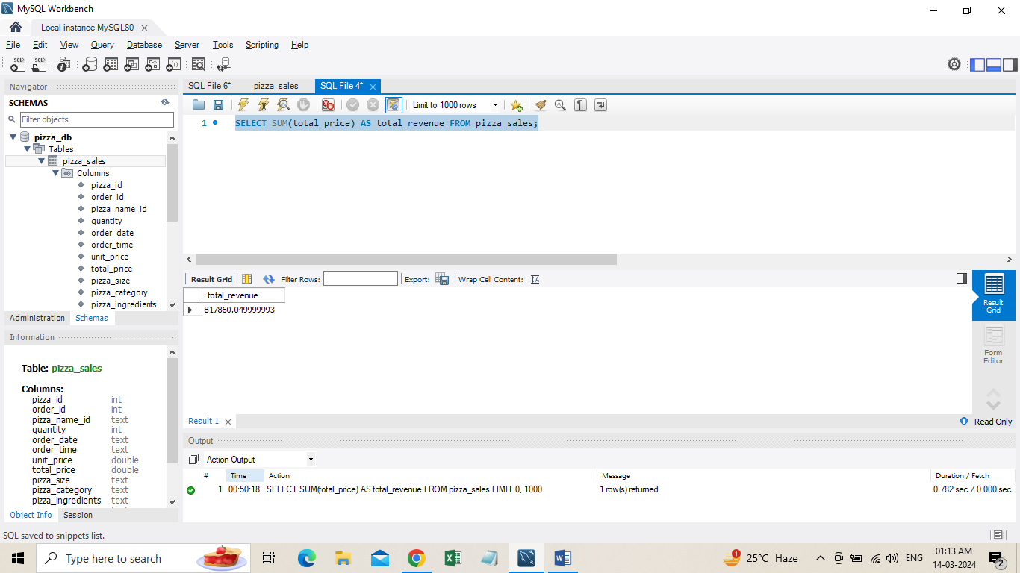

2. Average Order Value:

SELECT SUM(total_price) / COUNT(DISTINCT order_id) AS avg_order_value FROM pizza_sales;

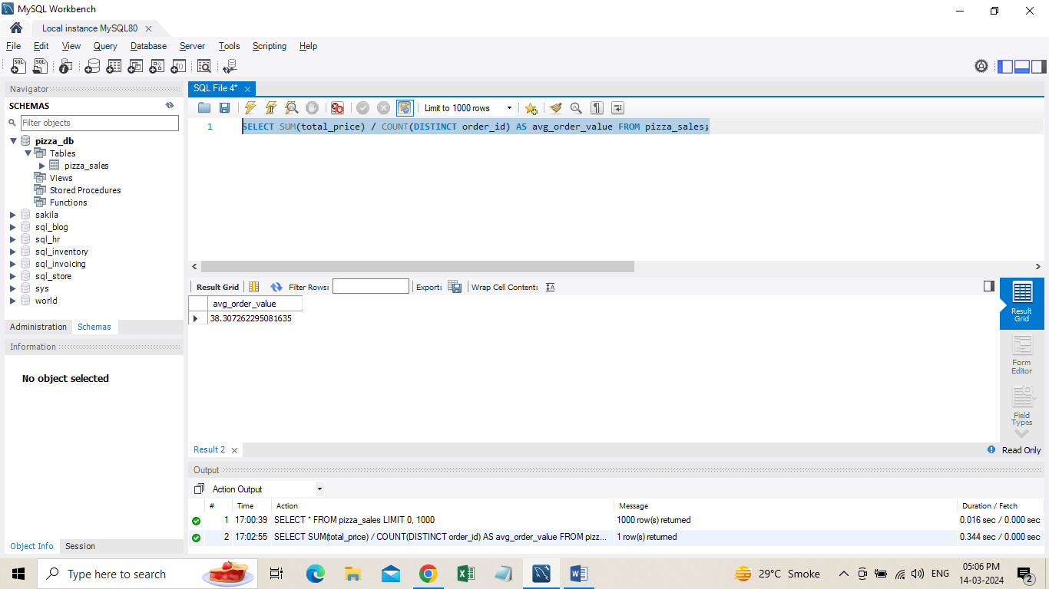

1. Total Pizza Sold

SELECT SUM(quantity) AS total_pizza_sold FROM pizza_sales;

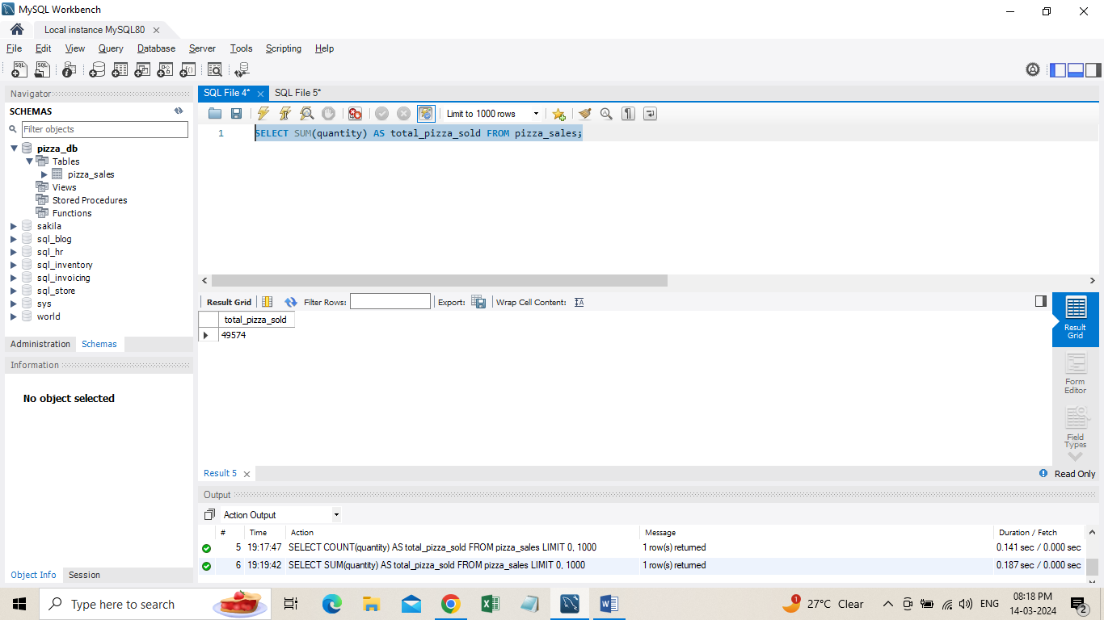

1. Total Orders

SELECT COUNT(DISTINCT order_id) AS total_order FROM pizza_sales;

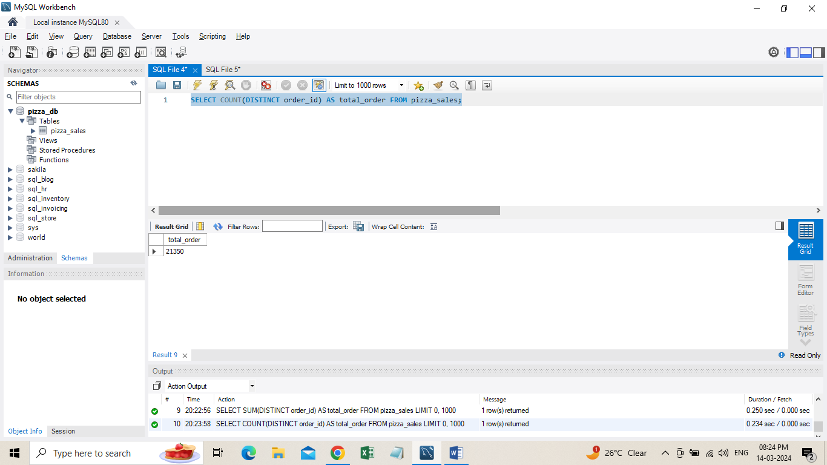

1. Average Pizzas Per Order

SELECT ROUND(SUM(quantity) / COUNT(DISTINCT order_id), 2) AS avg_pizza_per_order FROM pizza_sales;

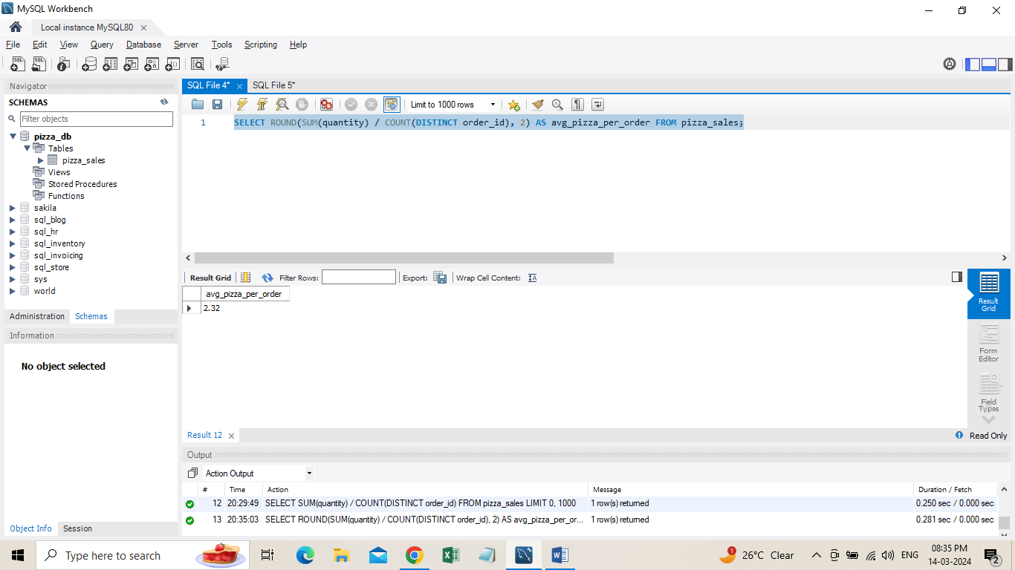

**B. Hourly Trend for Total Pizzas Sold**

SELECT HOUR(order_time) AS order_hours, SUM(quantity) AS total_pizzas_sold

FROM pizza_sales

GROUP BY HOUR(order_time)

ORDER BY HOUR(order_time);

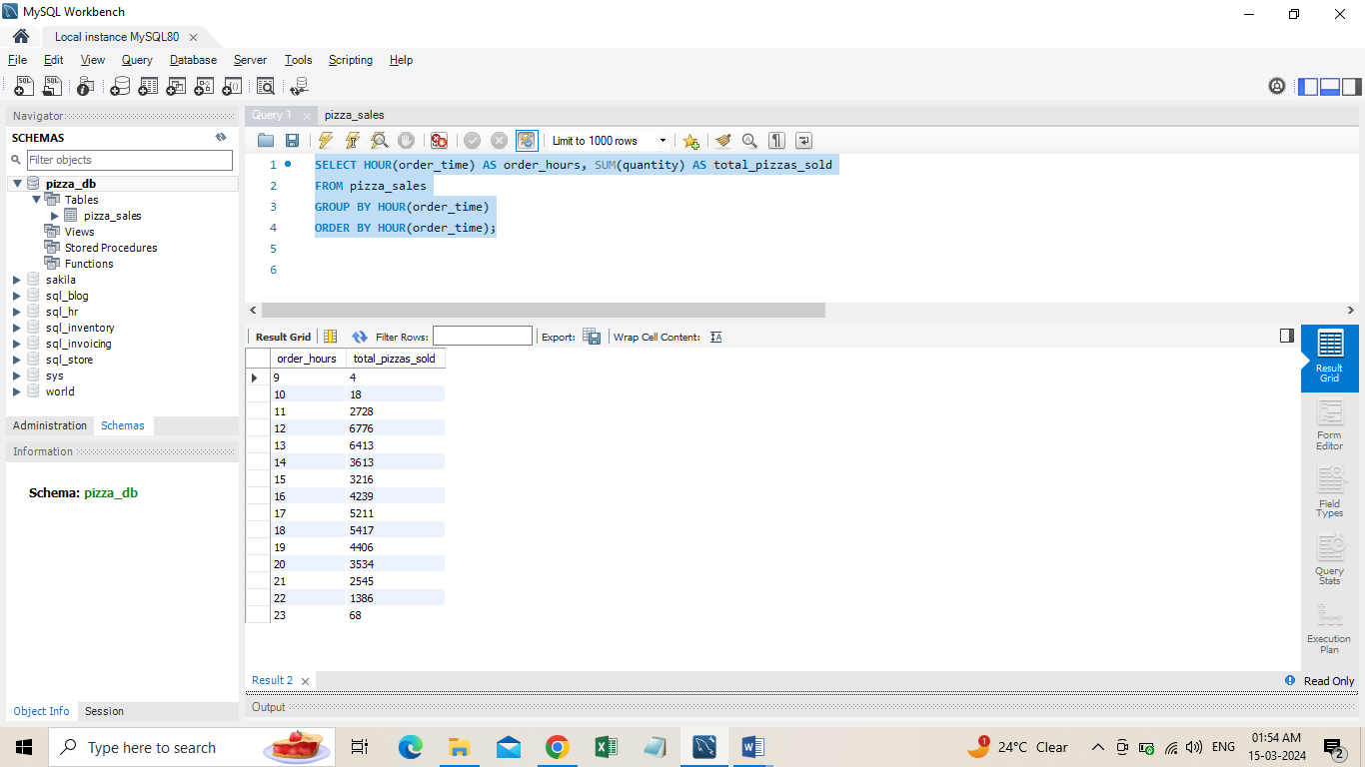

1. **Weekly Trend for Orders**

SELECT WEEK(order_date, 3) AS WeekNumber, YEAR(order_date) AS Year,

COUNT(DISTINCT order_id) AS Total_orders

FROM pizza_sales

GROUP BY WEEK(order_date, 3), YEAR(order_date)

ORDER BY Year, WeekNumber;

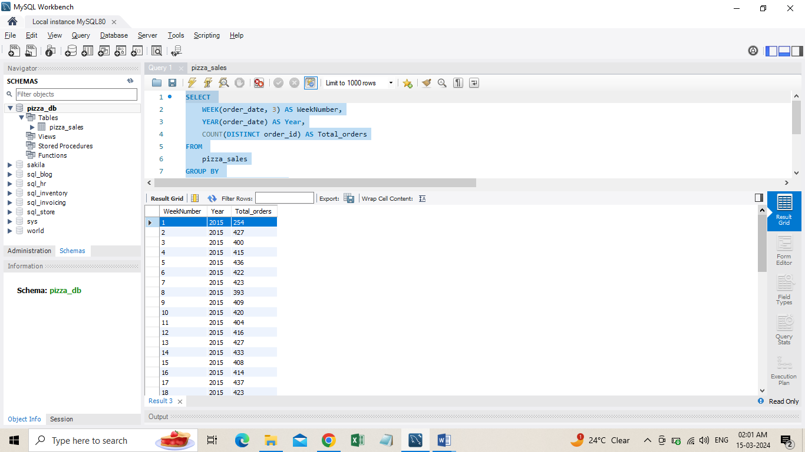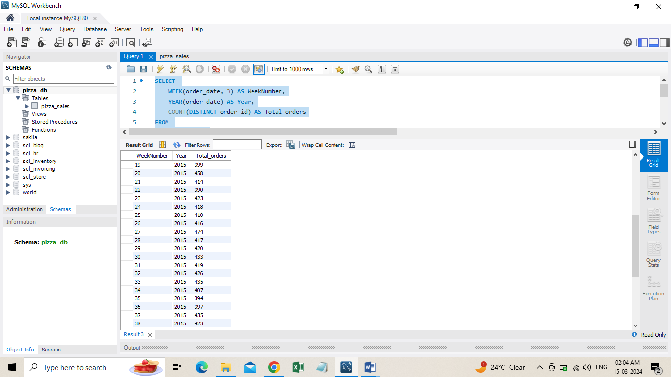

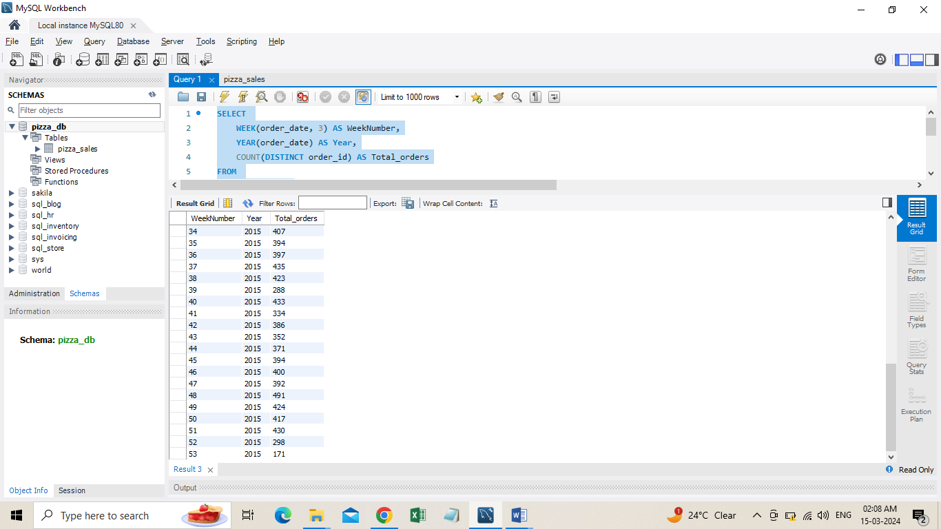

1. **% of Sales by Pizza Category**

SELECT pizza_category,

ROUND(SUM(total_price), 2) AS total_revenue,

ROUND(SUM(total_price) * 100 / (SELECT SUM(total_price) FROM pizza_sales), 2) AS PCT

FROM pizza_sales

GROUP BY pizza_category;

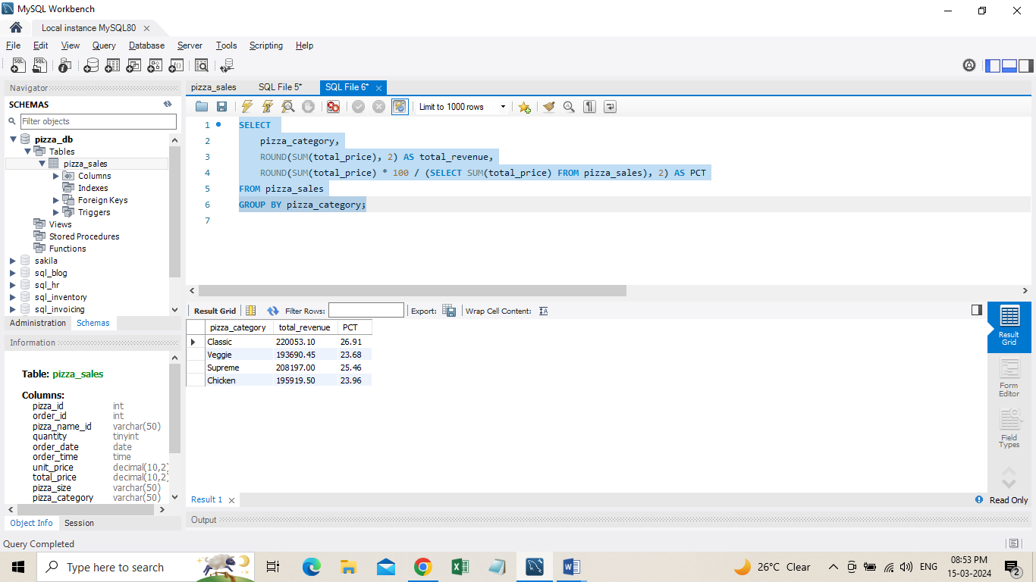

**OR**

SELECT pizza_category,

ROUND(SUM(total_price), 2) AS total_revenue,

ROUND(SUM(total_price) * 100 / (SELECT SUM(total_price) FROM pizza_sales

WHERE MONTH(order_date) = 1), 2) AS PCT

FROM pizza_sales

WHERE MONTH(order_date) = 1

GROUP BY pizza_category;

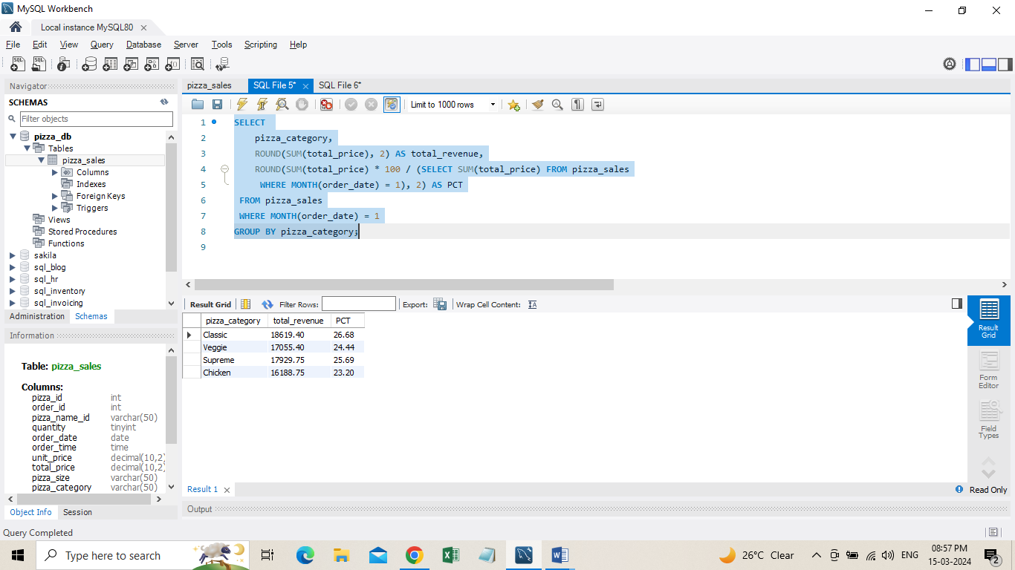

1. **% of Sales by Pizza Size**

SELECT pizza_size,

ROUND(SUM(total_price), 2) AS total_revenue,

ROUND(SUM(total_price) * 100 / (SELECT SUM(total_price) FROM pizza_sales), 2) AS PCT

FROM pizza_sales

GROUP BY pizza_size

ORDER BY pizza_size;

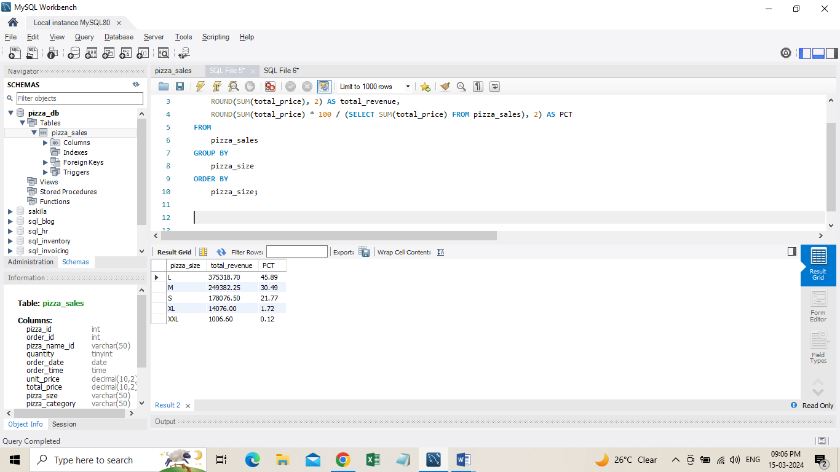

1. **Total Pizzas Sold by Pizza Category**

SELECT pizza_category, SUM(quantity) AS Total_Quantity_Sold

FROM pizza_sales

-- WHERE MONTH(order_date) = 2

GROUP BY pizza_category

ORDER BY Total_Quantity_Sold DESC;

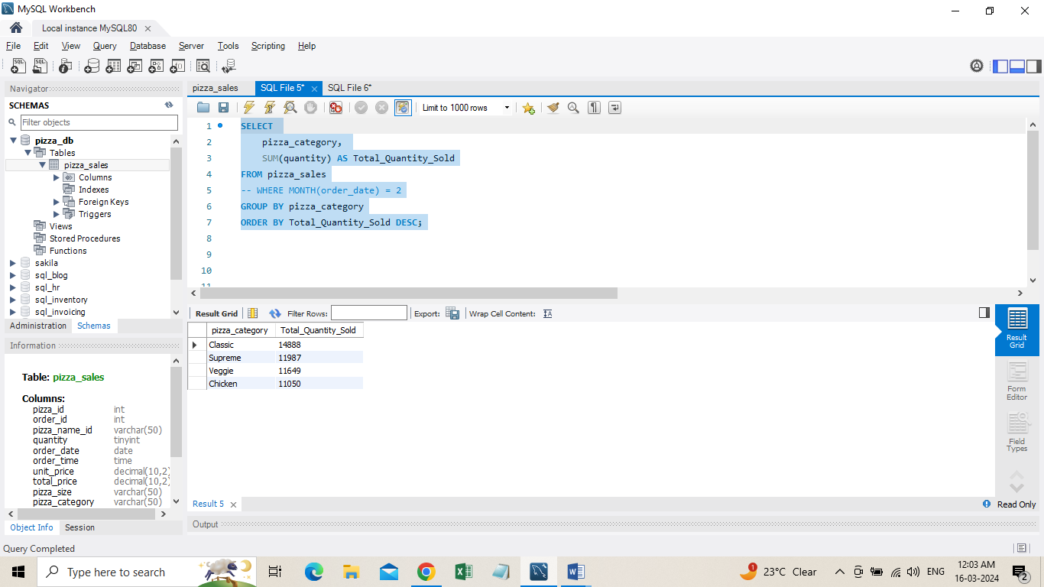

1. **Top 5 Pizzas by Revenue**

SELECT pizza_name, SUM(total_price) AS Total_Revenue

FROM pizza_sales

GROUP BY pizza_name

ORDER BY Total_Revenue DESC LIMIT 5;

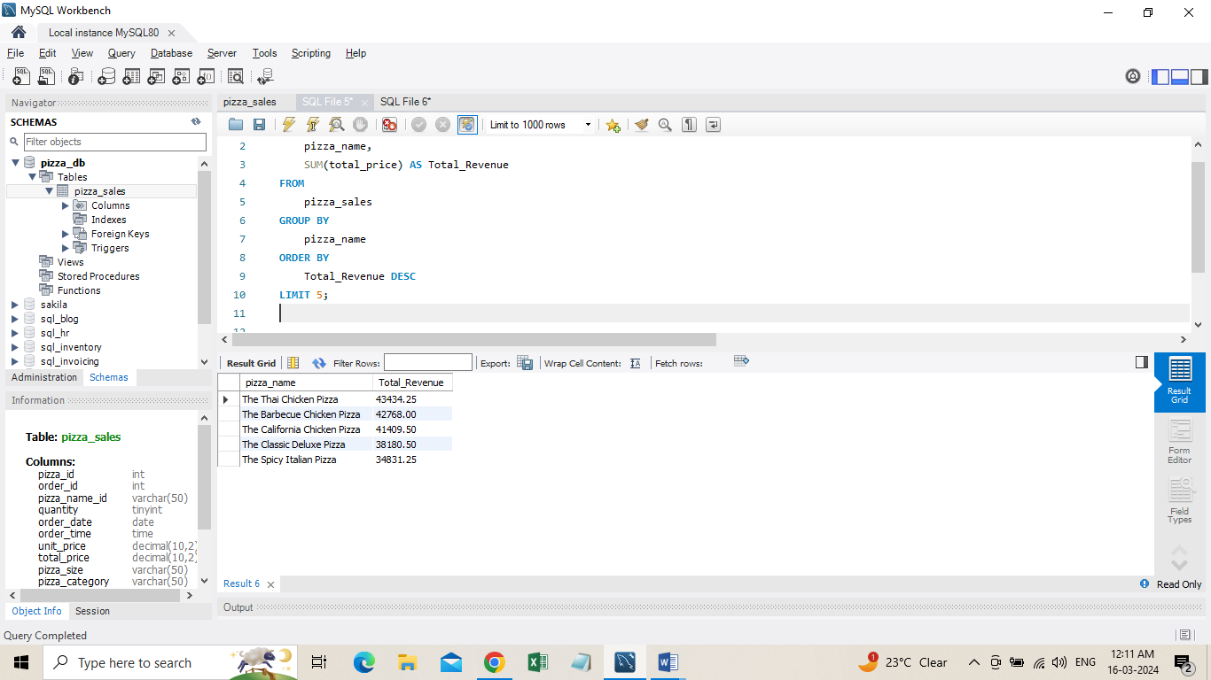

**H. Bottom 5 Pizzas by Revenue**

SELECT pizza_name, SUM(total_price) AS Total_Revenue

FROM pizza_sales

GROUP BY pizza_name

ORDER BY Total_Revenue ASC LIMIT 5;

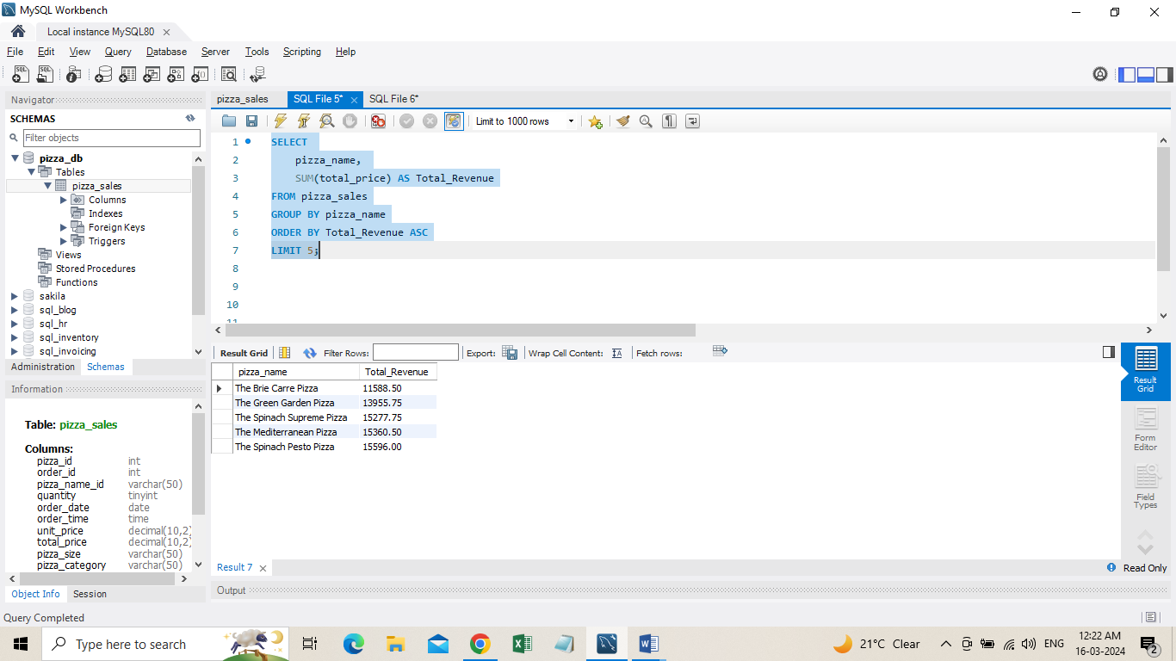

1. **Top 5 Pizzas by Quantity**

SELECT pizza_name, SUM(quantity) AS Total_Pizza_Sold

FROM pizza_sales

GROUP BY pizza_name

ORDER BY Total_Pizza_Sold ASC

LIMIT 5;

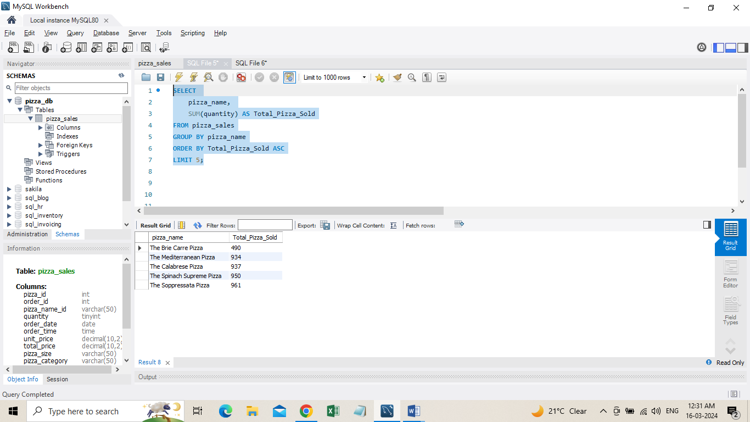

**K. Top 5 Pizzas by Total Orders**

SELECT pizza_name, COUNT(DISTINCT order_id) AS Total_Orders

FROM pizza_sales

GROUP BY pizza_name

ORDER BY Total_Orders DESC

LIMIT 5;

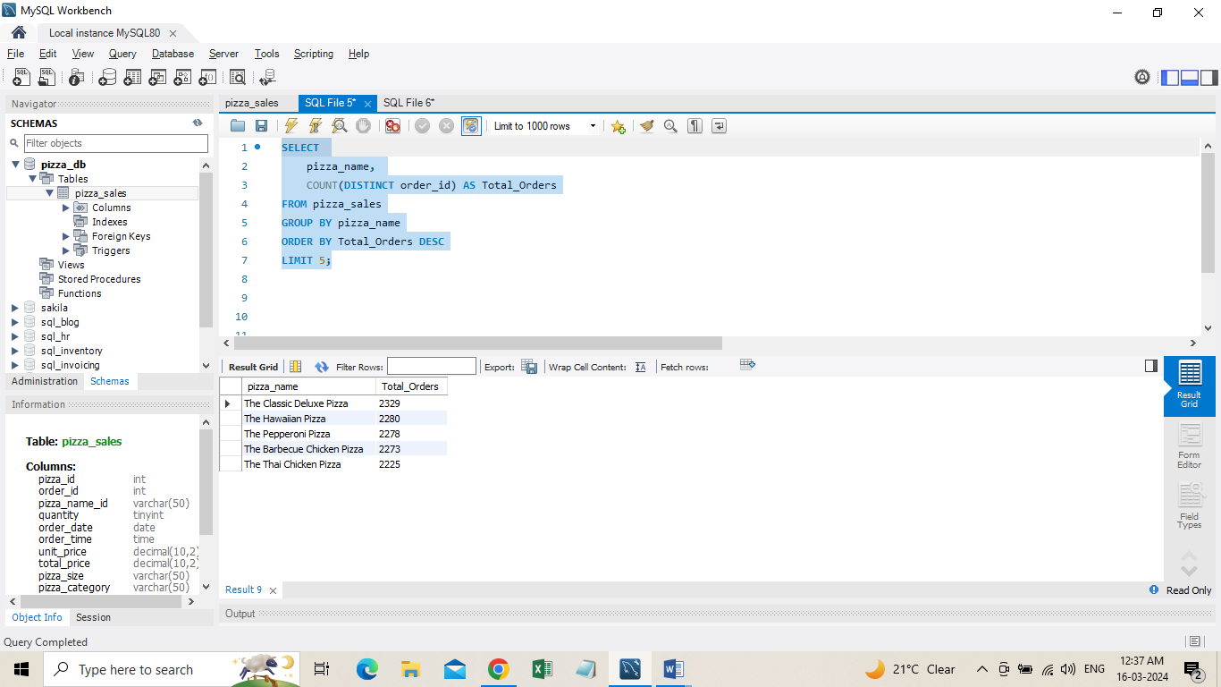

**L. Borrom 5 Pizzas by Total Orders**

SELECT

pizza_name,

COUNT(DISTINCT order_id) AS Total_Orders

FROM pizza_sales

GROUP BY pizza_name

ORDER BY Total_Orders ASC

LIMIT 5;

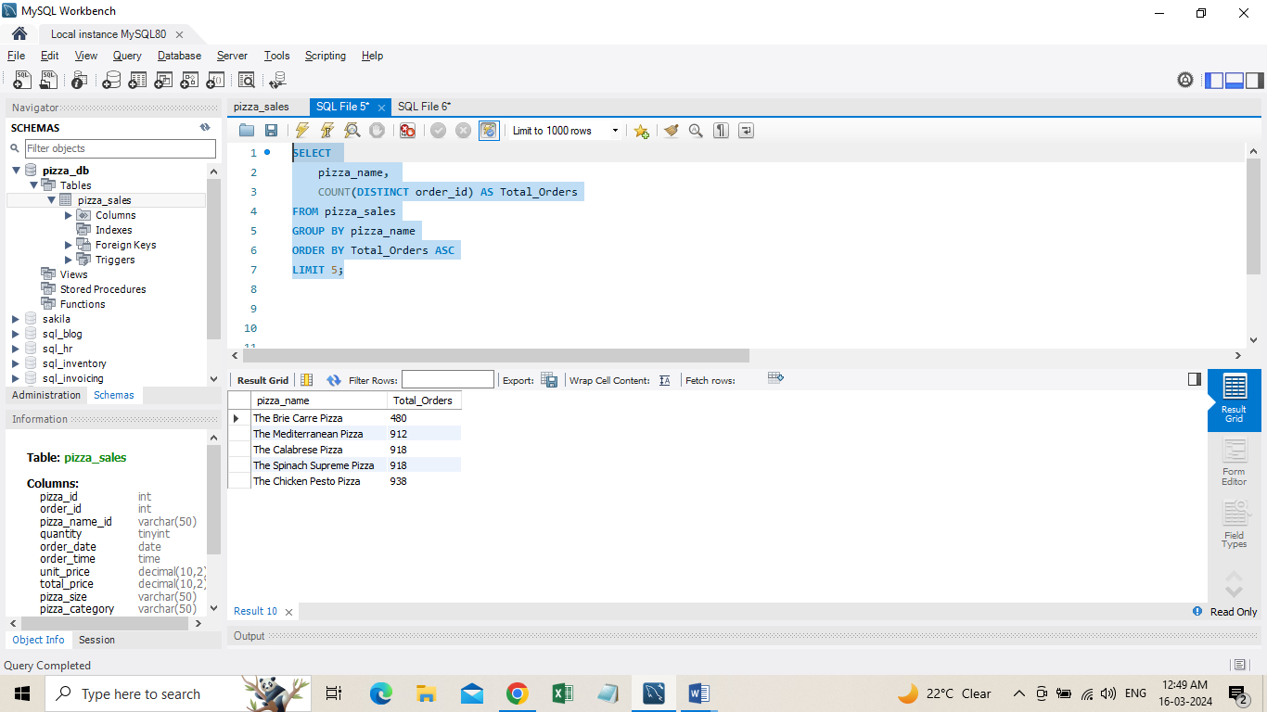

***NOTE***

If you want to apply the pizza_category or pizza_size filters to the above queries you can use WHERE clause. Follow some of below examples

SELECT pizza_name, COUNT(DISTINCT order_id) AS Total_Orders FROM pizza_sales

WHERE pizza_category = 'Classic' GROUP BY pizza_name ORDER BY Total_Orders ASC LIMIT 5;